Raspberry/Blueberry
Stuffed French Toast
The Fleur-de-Lys Mansion
Serves: 8
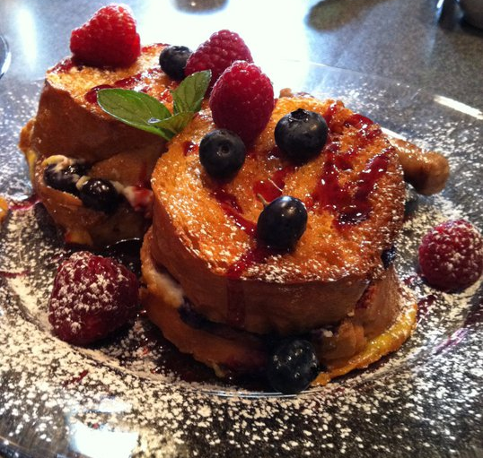
Ingredients
8 oz cream cheese, softened and whipped
Fresh blueberries
Raspberry preserves
Loaves of French bread
8 XL eggs
1 cup half & half
1 teaspoon vanilla
Raspberry plate scraper

Directions
Spray 11” by 13” Pyrex pan with no-stick spray. Slice bread ½” to ¾” thick. Spread cream cheese on half of slices. Place in pan and then press blueberries into cream cheese. Spread remaining slices of bread with raspberry preserves and place, preserve side down, on top of bread in pan to make sandwiches. Beat eggs and add half & half and vanilla. Pour slowly over sandwiches, making sure to cover each sandwich. Turn sandwiches over to soak up egg mixture. Drizzle with syrup and bake in 350 degree oven for approximately 20 minutes, or until tops of sandwiches are crisp and brown. Can be made the night before.

Syrup:
½ stick unsalted butter
½ cup brown sugar
¼ cup maple syrup
Mix together in small sauce pan until well mixed.

Serve two sandwiches on warmed plate drizzled with raspberry plate scraper. Sprinkle with powdered sugar and top with a few blueberries and raspberries.

